Cassandra Gucciardo
Name: __________________
Work Then Eat!

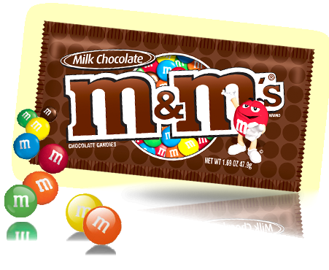

Objectives: The students will be able to review the measures of central tendency by determining mean, median and mode. They will review their understanding of estimation, sorting, graphing, fractions and percentage as well as probability (with and without replacement).

Materials:
- individual small bags of M&M’s
- copies of worksheets for each student
- pencils
- colored pencils or markers
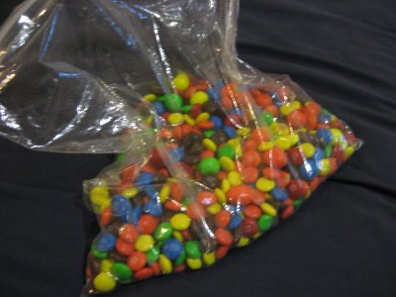

Procedure:
- Collect the Data
  - “Fractions and Percents Worksheet 1”
      - Using the information from your first page, convert each color into a fraction and a percent. Chart the color, fraction and percent.
  - “Make A Graph Worksheet 2”
      - Count each color M&M in your bag.
      - Make a bar graph for the different colors of candies in your bag.
      - Write the colors on the bottom of the graph and color using the same color crayon as the candy.
  - “Estimate, Predict, Actual Amount Worksheet 3”
      - Each student receives a plastic bag with M&M’s inside.
      - Before opening or touching your bag of candy, estimate how many are inside and record it.
      - Predict how many and which colors you will have.
      - Open your bag and find your actual total and how many you have of each color.
      - Record your results below.
  - “Mean, Median, Mode and Range Worksheet 4”
      - Find the mean of the M&M’s by taking the average and record it on the line.
      - Find the median of the M&M’s and record it.
      - Find the mode of the M&M’s and record it on the line provided.
      - Find the range by subtracting the highest colored M&M by the lowest colored M&M.
  - “Probability Worksheet 5” (with and without replacement)
      - Complete the first with replacement problem, and write your answer on the line below.
      - Complete the second without replacement problem, and write your answer on the line below.

Name: _____________________

Directions: Find the mean, median, mode and range and record them on the lines provided.

Mean, Median, Mode and Range
Worksheet # 4

Mean: _______________
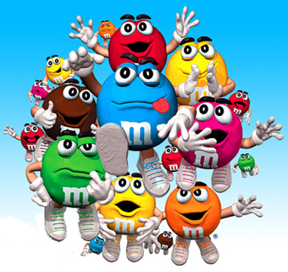
Median: _____________

Mode: _______________

Range: _______________

Name: ___________________
Directions: Answer the questions on probability. Show your work in the space provided.

Probability
Worksheet # 5

- Count the number of yellow M&M’s in your bag and total number of M&M’s in your bag, which you already know from the previous worksheets. What is the chance of selecting two yellow M&M’s with replacement?

- Now without replacement, what is the probability of selecting two yellow M&M’s?

Name: ________________

Fractions and Percents
Worksheet # 1

Fraction Chart (Ex: 3/10)
Yellow
Orange
Blue
Red
Brown
Green

Percentage Chart %
Yellow
Orange
Blue
Red
Brown
Green

Name: ________________
Estimate, Predict, Actual Amount!
Worksheet # 3
Without opening or touching your bag of candy, estimate how many are inside and record below. Predict how many and which colors you will have. Then, open your bag and find your actual total and how many you have of each color. Record your results below.
Estimated total:  ______ | Actual total:  ______

Colors | Prediction | Actual Amount
Total:
_______

Name: ________________
Make a Graph
Worksheet # 2
Directions: Make a bar graph for the colors of M&M’s in your bag. Write the colors on the bottom of the graph and color using the same color crayon as the candy.

Colors

